Mapping Impervious Surfaces in the Willow Brook Watershed
Complex Systems Research Center
March, 2011

The GRANIT staff at the Complex Systems Research Center, University of New Hampshire , mapped impervious surfaces for the Willow Brook watershed (2,515 acres) in Rochester, NH. This document provides a brief overview of the methodology used, and summarizes the results of the mapping effort.

The first step was to delineate the Willow Brook watershed. This was done using standard ArcGIS (v10) watershed tools applied to a digital elevation model derived from the National Elevation Dataset (NED) as of the summer of 2010. Generally described, the watershed boundary was delineated by creating a pour point near the confluence of Willow Brook and the Cocheco River (-70.9758 longitude, 43.2824 latitude), and selecting all upstream pixels that flow into that location. The derived raster was then converted to a vector feature class representing the boundary of the watershed.
Impervious surfaces were then delineated for the watershed based on 1-foot resolution aerial photography collected in April of 2010. Impervious surfaces were mapped into the following categories:
Code Description
1 Asphalt roads
2 Asphalt driveways
3 Compacted gravel/soil
4 Asphalt parking
5 Rooftops
6 Other asphalt (e.g. sidewalks and other asphalt areas that do not fit the above categories)
7 Other built ( e.g. patios and decks around buildings and swimming pools, probably somewhat
pervious)

The processing involved identifying and mapping impervious surfaces within the newly created watershed boundary. This step progressed by interpreting visible features in the aerial photography and automating each by screen-digitizing the extent into individual polygons and coding its type (as described above) into the appropriate impervious surface category.
Table 1 lists the acreages for the various impervious surface categories cross-tabulated by land use category. (The land use data was derived from 1-foot resolution aerial photography acquired in 2005, and is available from the GRANIT data archive.) Figure 1 shows an overview of the Willow Brook watershed along with a generalized representation of the mapped impervious surfaces. Figure 2 shows a large scale view of an area within the watershed with the individual impervious categories discretely symbolized. Figure 3 displays the 2005 land use delineation and distribution for the Willow Brook watershed.

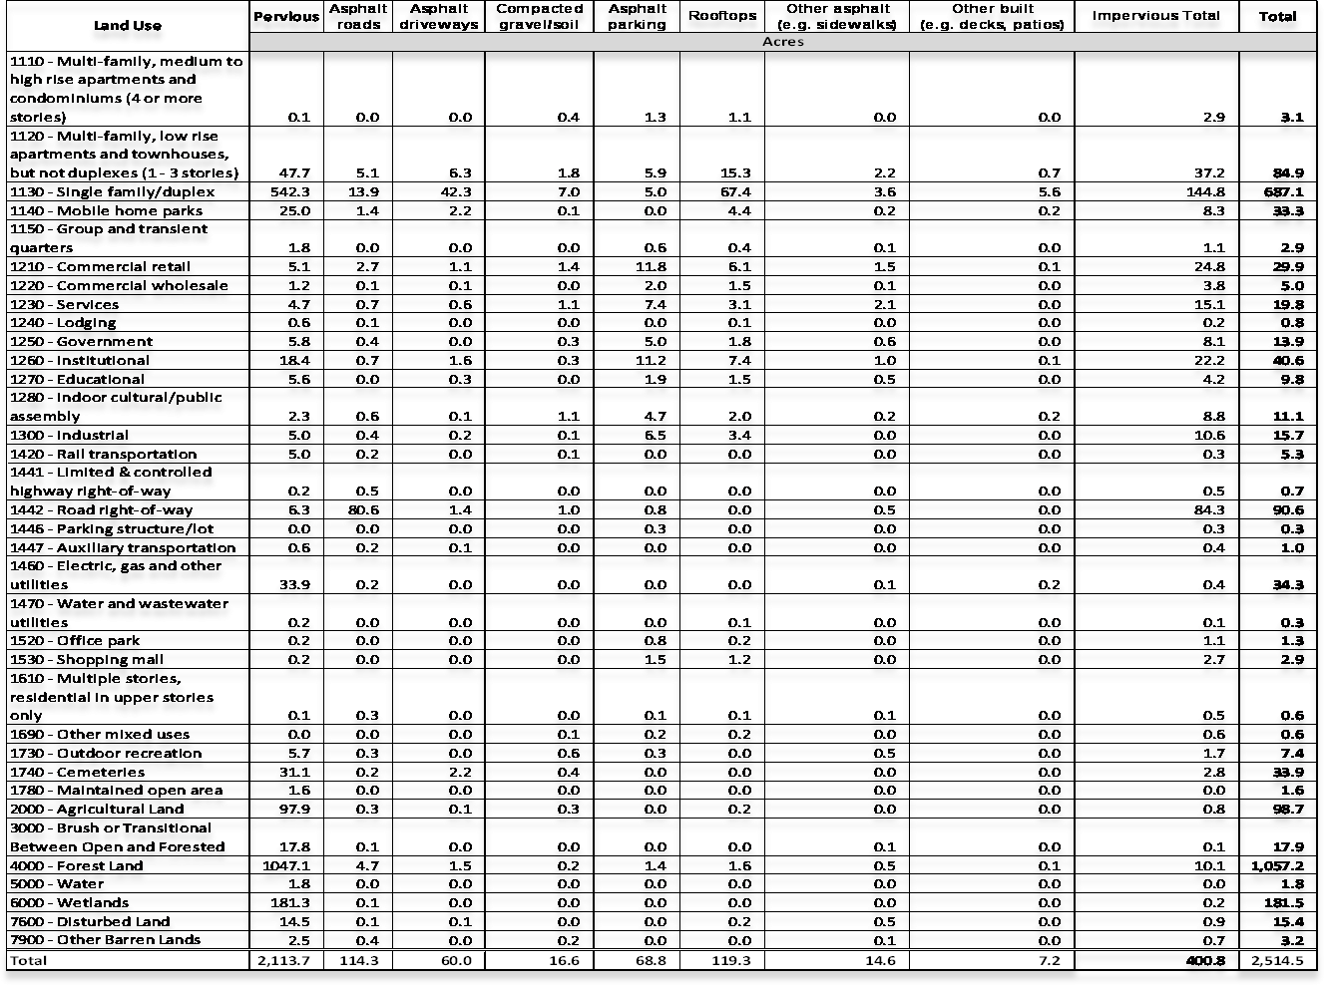 Table 1. Impervious surfaces by type and land use category for the Willow Brook watershed. (All figures reported in acres.)

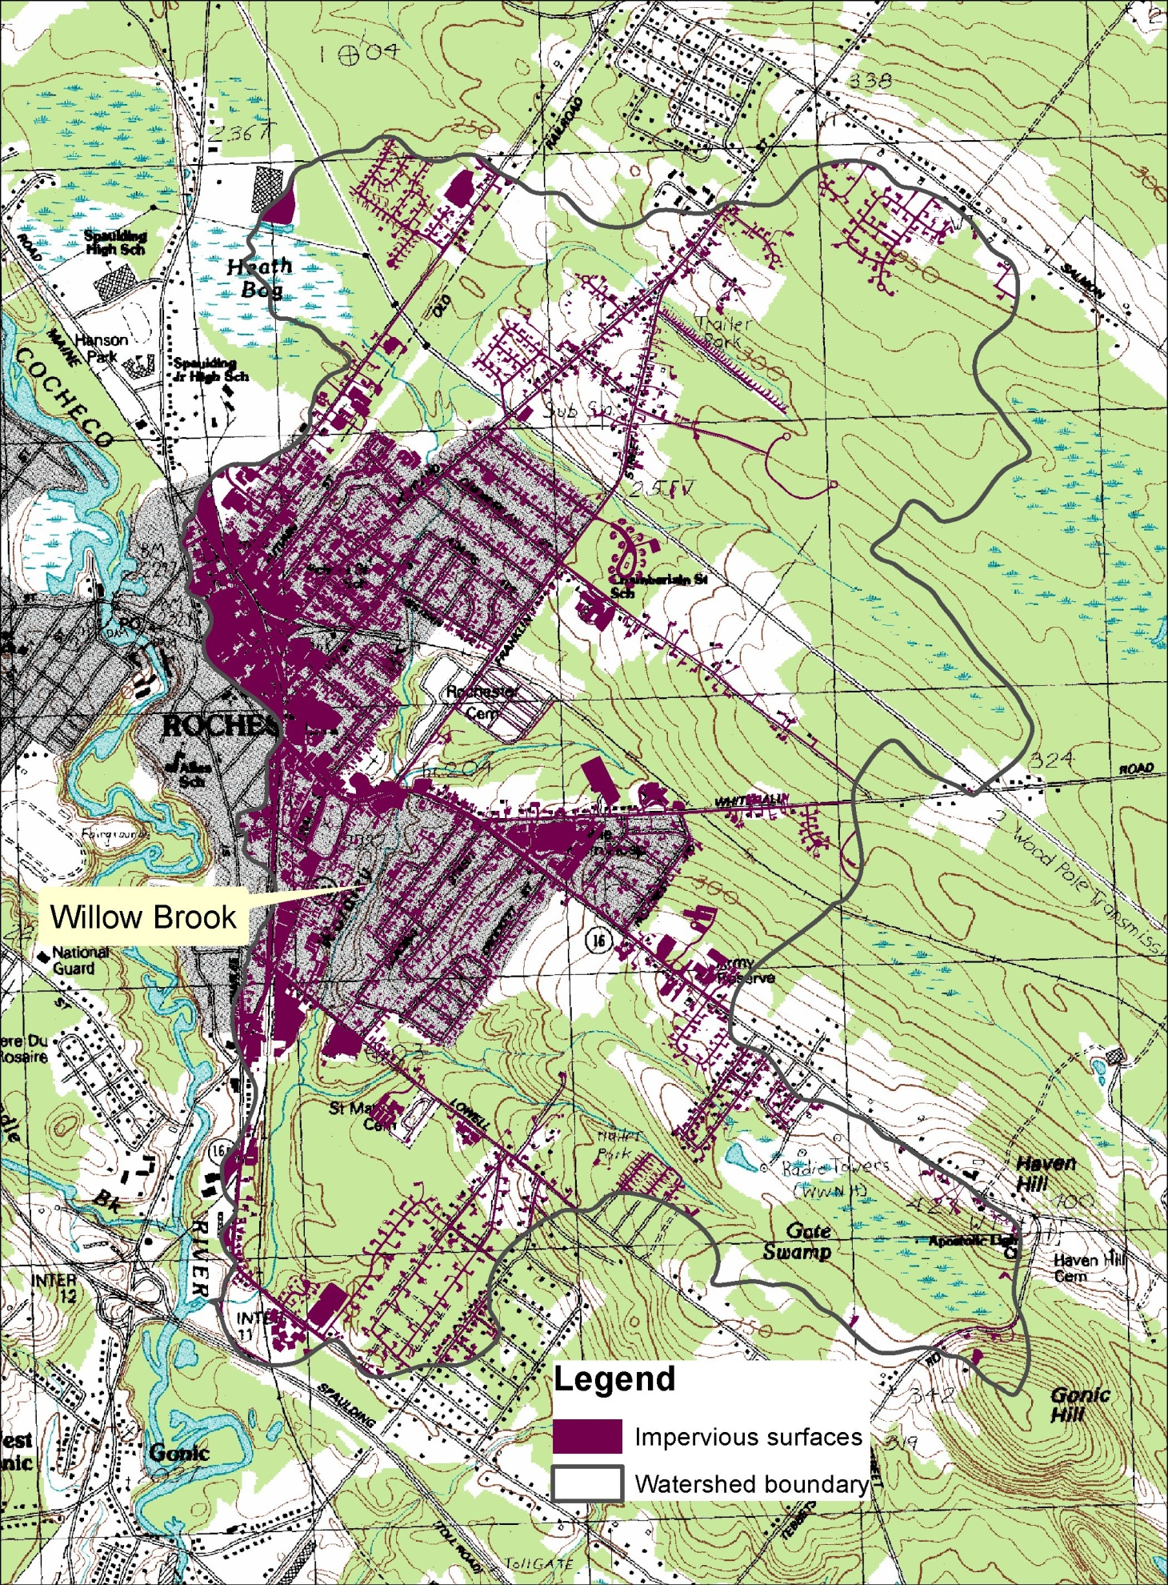 Figure 1. Impervious surfaces within the Willow Brook watershed.

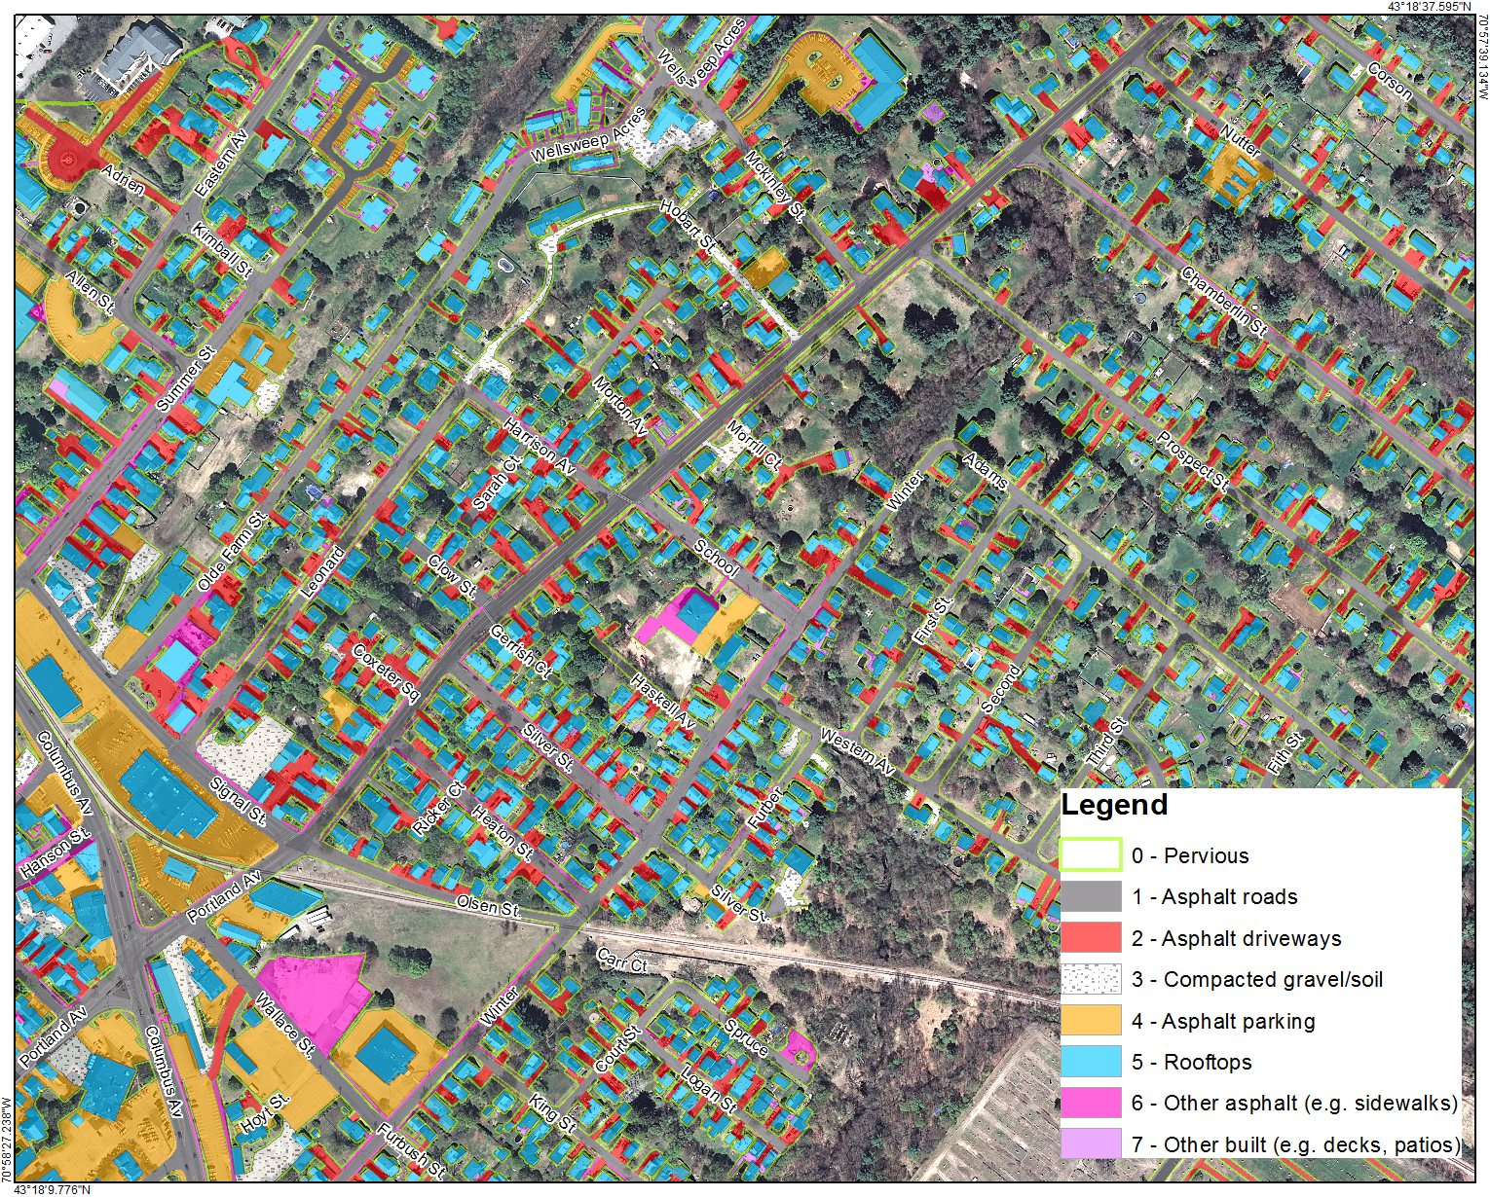 Figure 2. Large scale view of impervious surfaces in the Willow Brook watershed

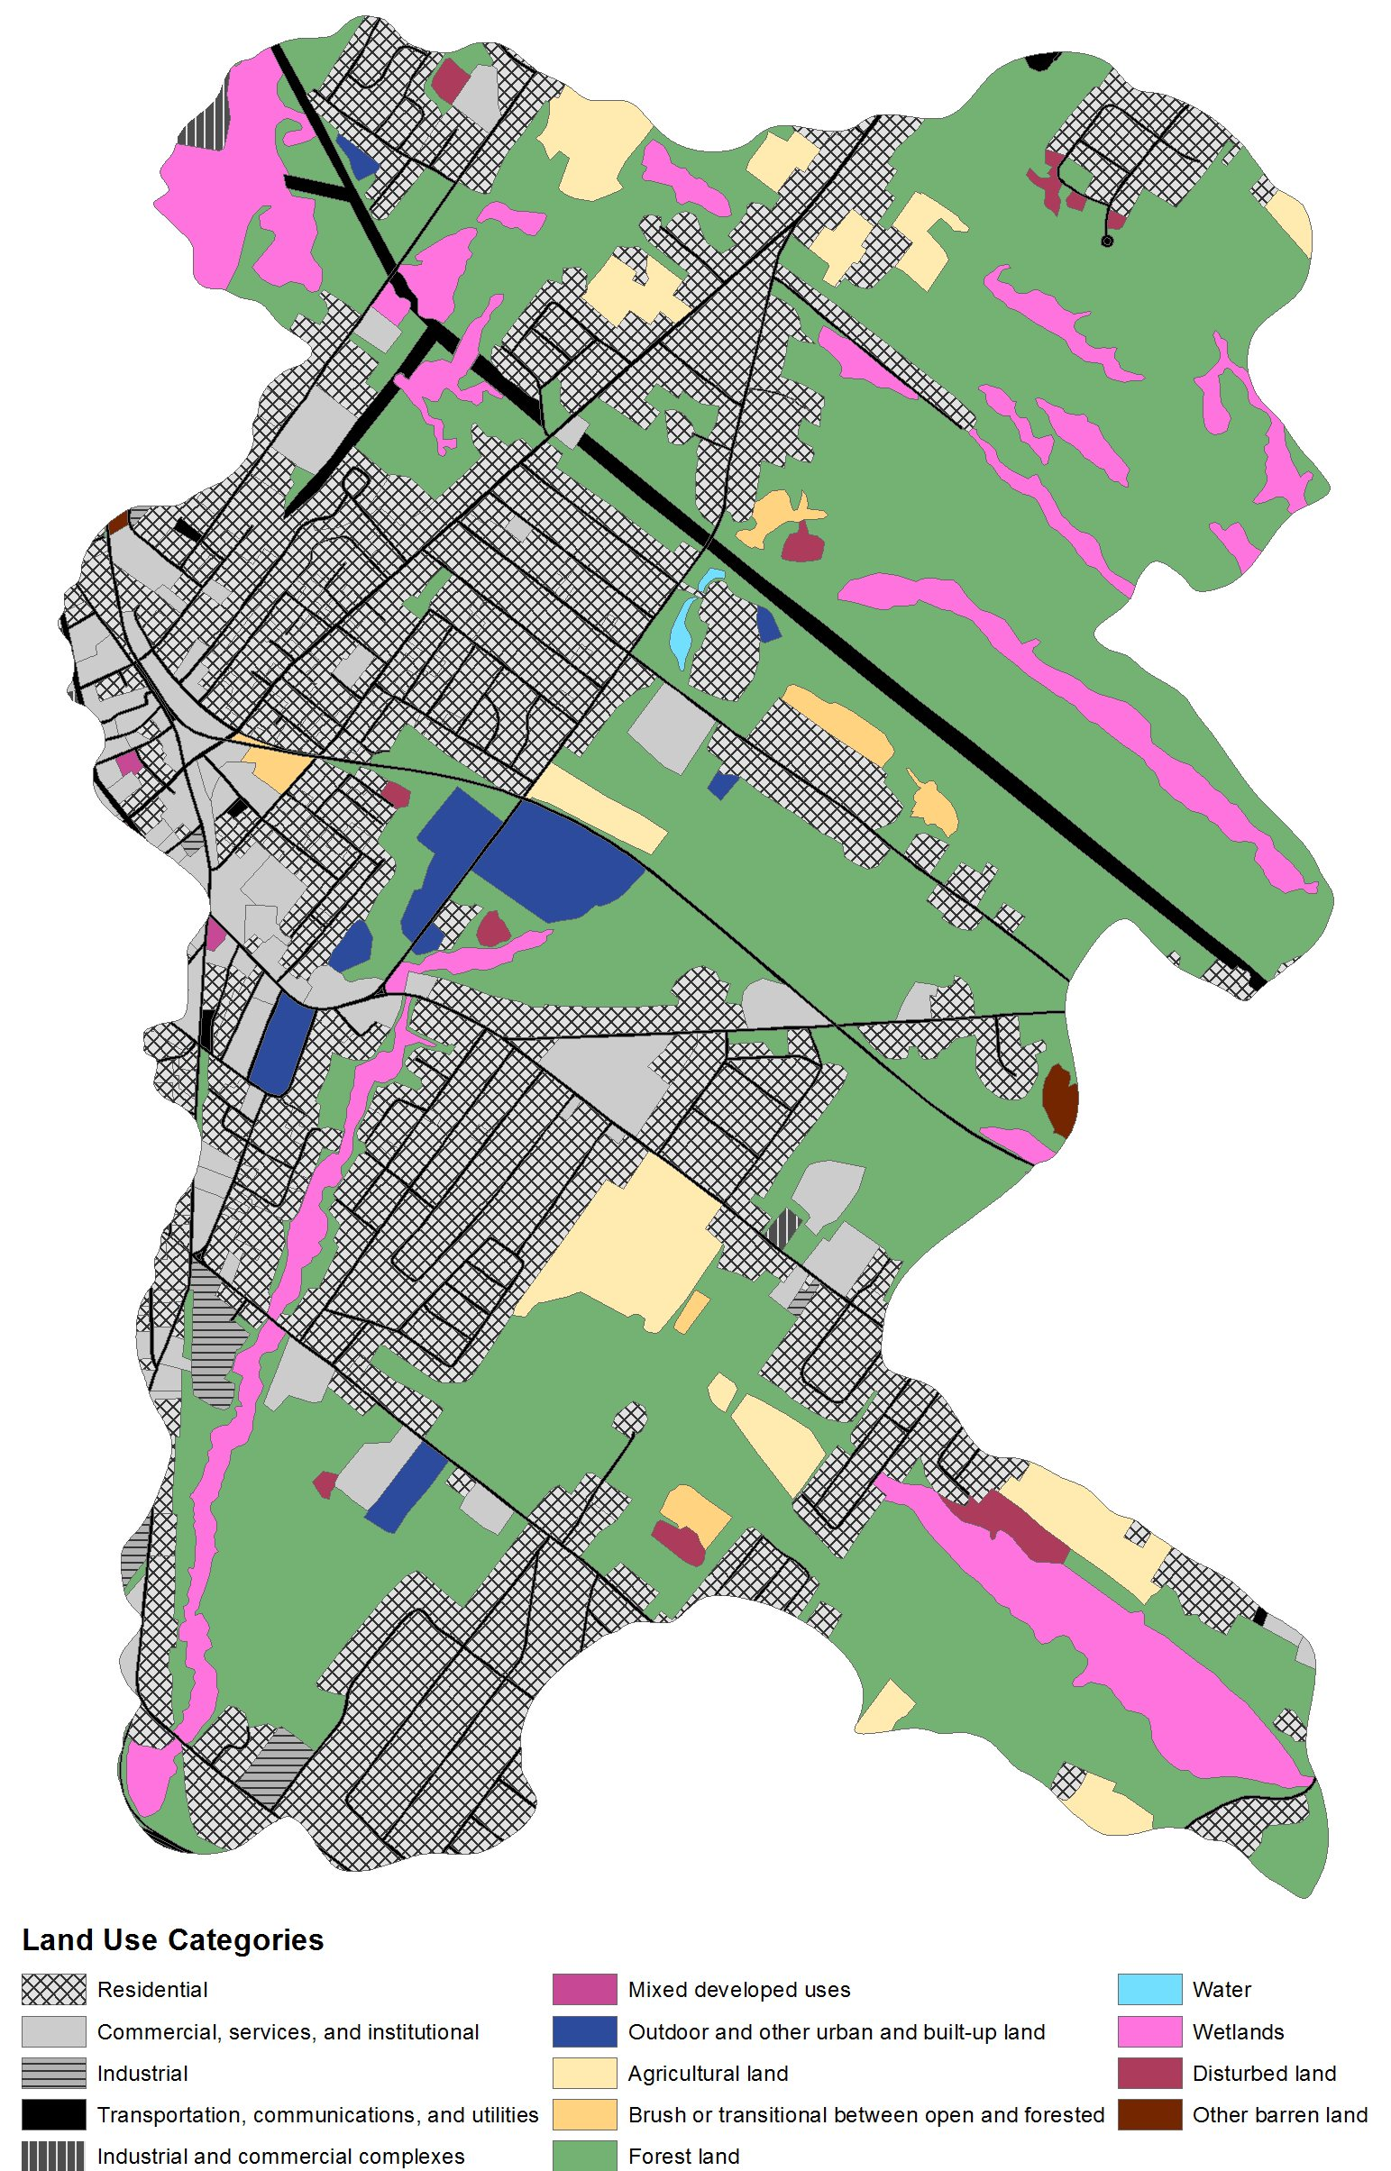 Figure 3. 2005 Land use for the Willow Brook watershed.

