Municipal Board Empowerment Series Workshop #7
NH Coastal Viewer 201

http://nhcoastalviewer.org

Exercises
Evaluating Land Protection Priorities
September 6, 2017

NH Coastal Viewer Training Exercise: Using the NH Coastal Viewer for Land Protection
This exercise will illustrate how the NH Coastal Viewer may be used to prioritize parcels within your town for future land protection efforts. It presents a series of steps that will help you answer this question by A) conducting a visual assessment and B) by using some of the available analytical and measurement tools. The exercise assumes that you have some familiarity with the Viewer, including how to find and display data layers and how to navigate within the map display. Guidance is provided at the start to re-acquaint you with some of the basic tools.
Sample map generated by Part A of following exercise:

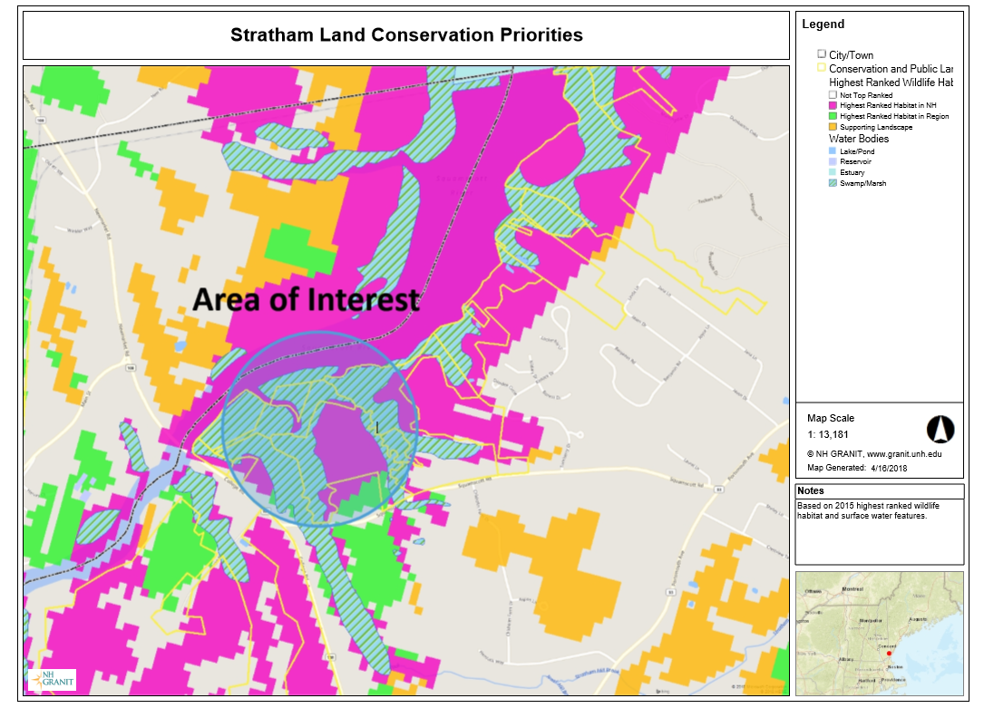

Part A. Begin by accessing the NH Coastal Viewer from http://www.nhcoastalviewer.org
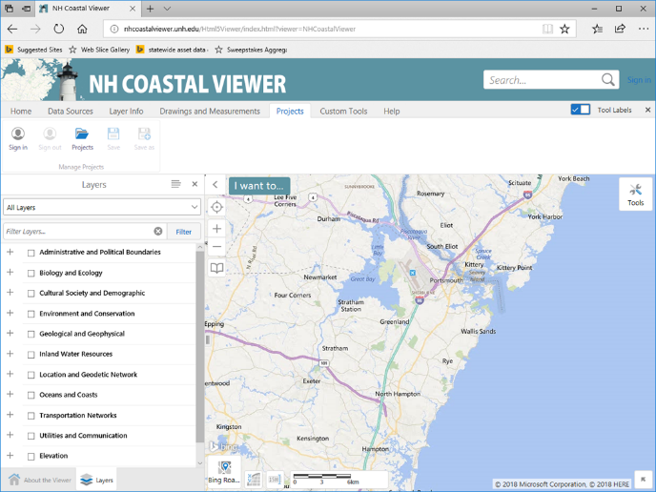
- Login to ArcGIS Online (AGO) so that you can save your project results later. Note that it is helpful to get in the habit of doing this when you first access the Coastal Viewer, as any customized views you create by zooming/panning, turning on data sets, resymbolizing data, adding text/graphics, etc., will only be saved to the project file if you are logged in from the start of the session.
  - Click the Projects tab in the top navigation bar.
  - Click on Sign in and enter your AGO credentials.

- Turn on Data Layers
  - Display the Town/City boundary layer from within the Administrative and Political Boundaries (APB) folder on your map by checking the appropriate boxes.
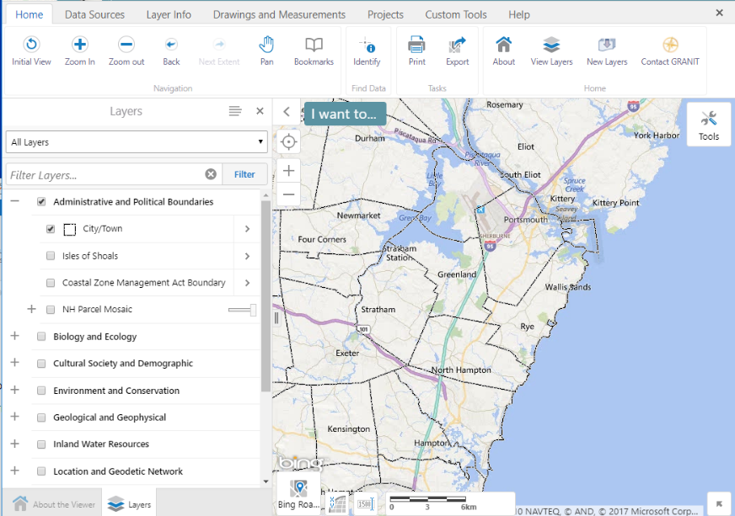
  - Expand and collapse data categories by clicking the +/- symbols. Here, start by expanding the APB folder.
  - Check both the folder name and the City/Town layer. Note that all levels of the hierarchy must be checked for data to be visible.
- If you accidentally close the Layers panel, you can open it again by clicking the View Layers tool (found in the Home tab of the toolbar).
- Try expanding other folders and displaying additional data sets of interest. Remember to expand and click on all levels of the layer hierarchy to fully expand folders and display a data set.
  - Note: Layers in the Layer List that appear in gray font are scale-dependent and will only draw when the map is zoomed in and the font color changes to black.
- Navigate to your Town of Interest and Establish a Bookmark

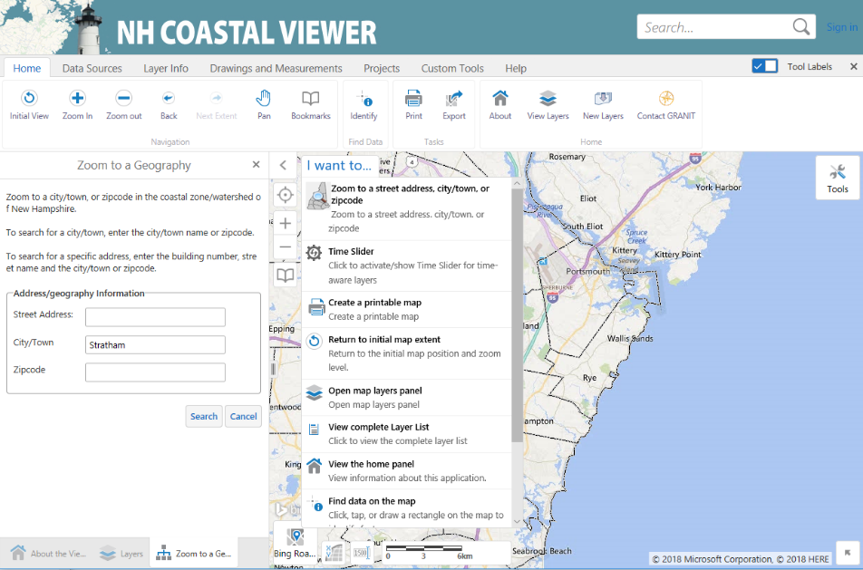
  - One way to zoom to a location of interest is to use the Zoom to a street address, city/town or zipcode option in the I want to ... menu. This will open the Zoom to a Geography panel.
  - Enter a town of interest in the City/Town text box. As you start to enter the text, select from one of the “autocomplete” options in the dropdown menu. This exercise uses the town of Stratham for illustration purposes.
  - Click on Search to zoom in and reposition the map. The remainder of your analysis will be based on the full map extent displayed (and not just on your town of interest). Close the Zoom to a Geography panel by clicking on the “x” in the upper right corner.

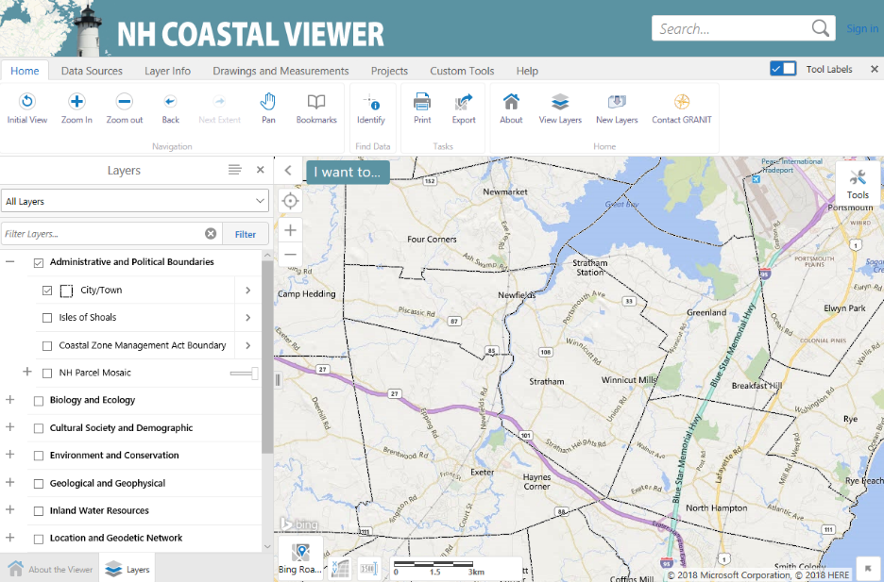
  - Click on the Bookmark tool so that you can set a bookmark and easily return to this map extent. Click on “Bookmark Current Extent”, enter a meaningful name in the “Bookmark Name” textbox and click “OK”. Click anywhere on the map to close the Bookmarked Locations textbox. You can then return to this geographic extent at any time by clicking on the Bookmark tool again and selecting the appropriate Bookmark name.

- Display and Organize Additional Data Layers

- Display the Conservation and Public Lands, Wildlife Action Plan: Highest Ranked Wildlife Habitat, and Water Bodies data layers. These data sets will be helpful in visually assessing what parcels of land may be appropriate to target for future conservation efforts.

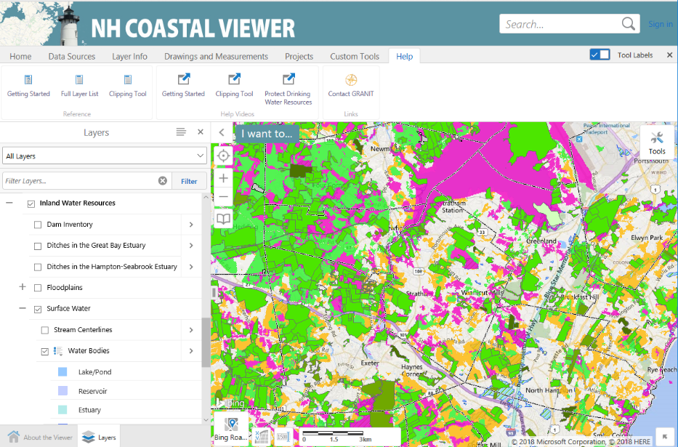
- There are several ways to locate these data layers in the Layer List if you don’t know where to find them. One option is to click on the Help tab, open the “Full Layer List” document, and search for the layer name.

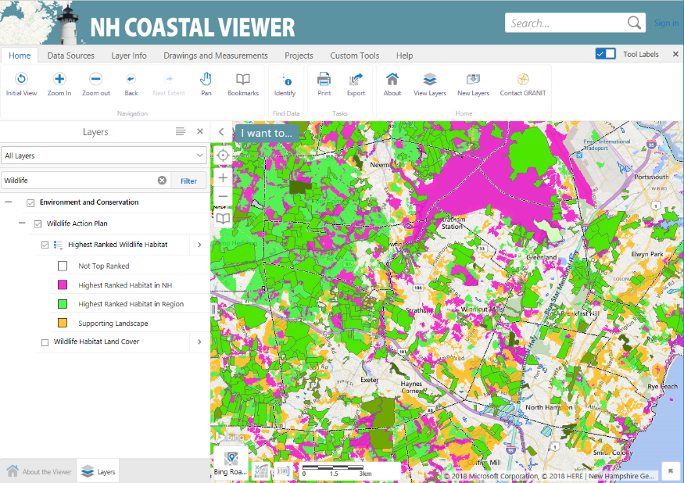
- Another option is to enter part or all of the data set name in the Filter Layers text box, and then click on Filter. Try entering “Wildlife” in the Filter text box to find the location of the Highest Ranked Wildlife Habitat data set in the Layer List. (If you use this option, remember to “x” out of the Filter box when you are done to recall the full list of data sets.)

- Notice that it is difficult to discern features in your map display. The color of the “Highest Ranked Habitat in Region” is close to the “Conservation and Public Lands” color. In addition, it is impossible to see the “Water Bodies” because they are displayed underneath the wildlife data set.

- First, change the symbology associated with the Conservation and Public Lands data set so that the parcels are outlined in aqua (but not shaded).

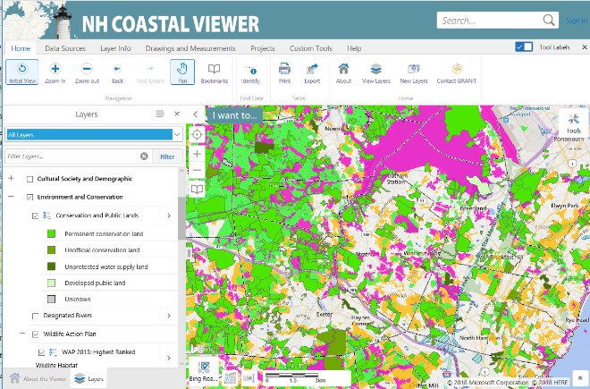
  - Click on the “>” sign to the right of the layer name to open the Layer Actions menu for the Conservation and Public Lands data set.

Question: When was this data set last updated?

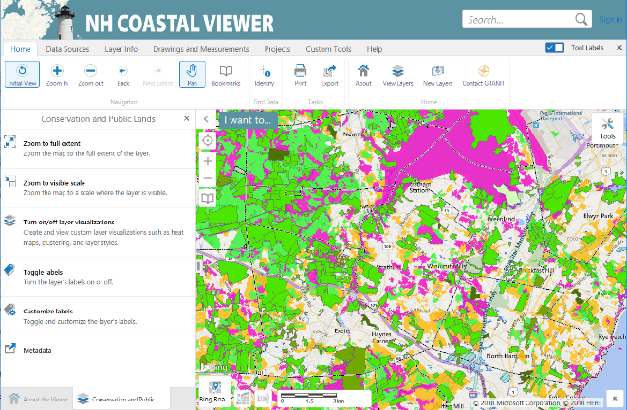
  - Click on “Turn on/off layer visualizations” to change the way the data are displayed (or visualized).

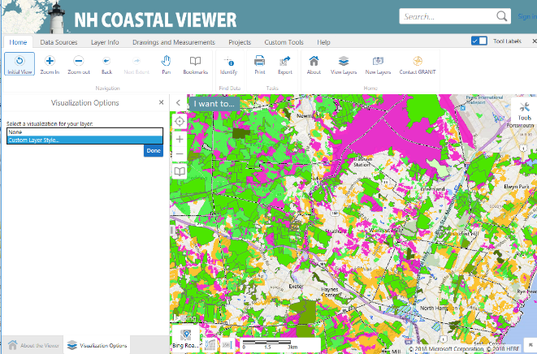
  - From the dropdown menu, select “Custom Layer Style”.

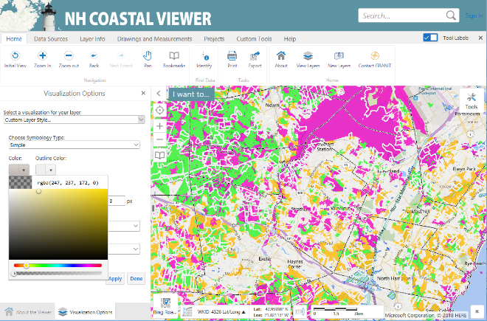
  - Explore the options for changing the fill color and style and the outline color and style. To eliminate the interior shading of the conservation tracts, click on the “Color” box and move the transparency slider at the bottom of the color picker all the way to the left. This makes the shading 100% transparent.

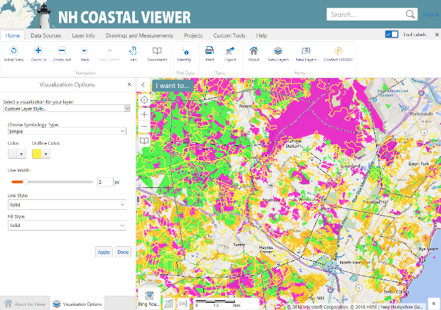
  - Click on the “Outline color” box and select yellow (or any color you choose). Click Apply to see the results and Done when you are satisfied with the symbols. (Note that you can select “None” for the Visualization option at the top of the panel to return to the initial display.) Close out the Visualization Options panel and the Layer Actions panel.

- Next, we will change the draw order of the data layers so that water bodies display on top of the wildlife data.

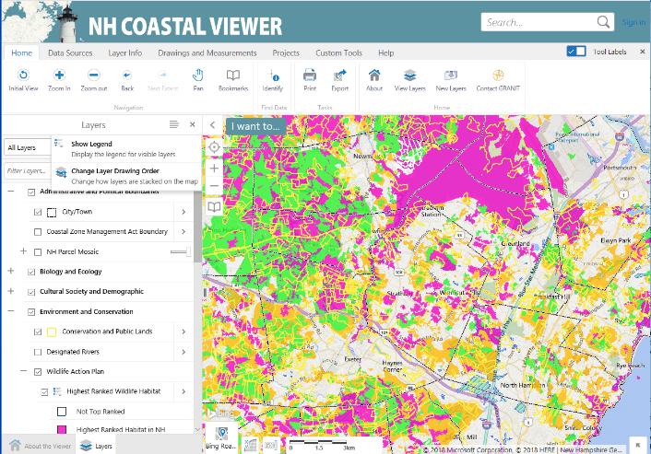
  - Begin by opening the Panel Actions Menu to the upper right of the Layer List and select “Change Layer Drawing Order”.

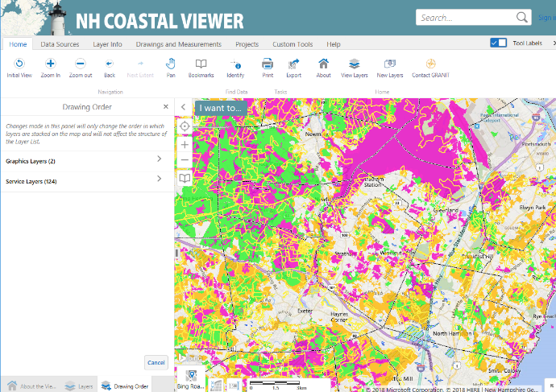
  - In the Drawing Order panel, select Service Layers.

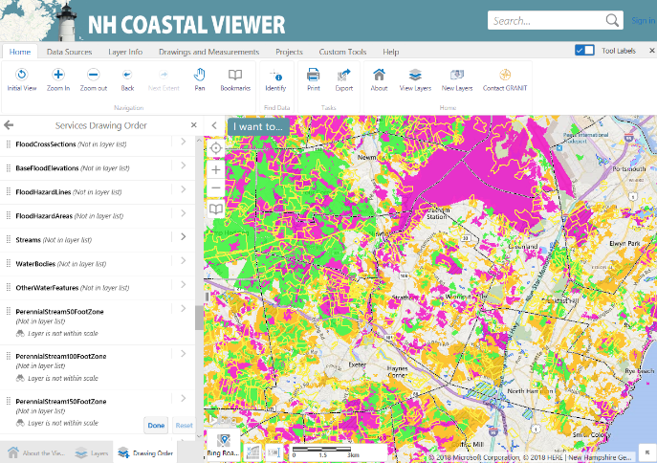
  - You will see a listing of all layers in the Layer Listing panel. Scroll down until you find the “WaterBodies” layer. If you click on the layer name, you can use the arrows to move this data layer up or down in the list incrementally. In this case, we want to move the data layer so that it appears above the wildlife data set. The fastest way to accomplish that is to click on the rectangular “dots” and drag the data layer to its new position.

  - Close out of the Services Drawing Order panel and the Drawing Order panel. Zoom into your map around a location of interest and explore areas where there are highest ranked wildlife habitat features in close proximity to surface water bodies and existing conservation lands. These are areas you may want to consider for future land protection.

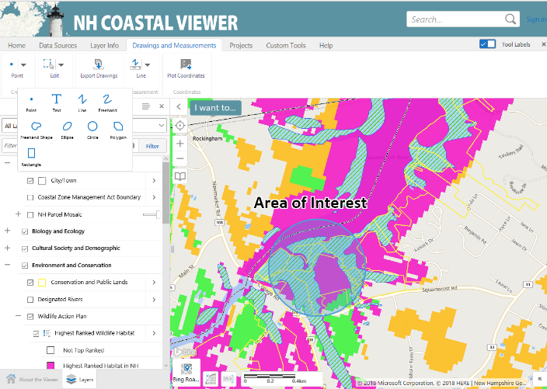
  - From the Drawings and Measurements tab, select the “Circle” graphic option to drag a circle on your map around a location of interest. Try using the “Text” tool to incorporate a label on your map as well. When you are done, return to the Home panel and grab another tool so that you release the graphics tools. (Once placed, you can change the text font by clicking once on the text string and using the “Styles” option. You can also change the size of the font grabbing the “handles” around the text box and expanding, and/or move the placement of the text.)

  - Using the instructions from the previous exercise, save your project file so that you can return to it later and/or share it with colleagues.

  - You may also want to use the Print option on the Home panel to generate a map that you can then print locally.

Part B. To begin the next part of this exercise, return to the Layer Listing and click off all data layers except for the City/Town boundaries. Clear any graphics from your map display by clicking on them and deleting them. From the Home panel, return to the original map extent by clicking on the “Initial View” option. If easier, you can opt to simply re-launch the Coastal Viewer. However, remember to log back into ArcGIS Online if you do so, and to turn on the City/Town boundaries.
- Zoom In and Display Data Sets.

- Use one of the available tools to zoom to a coastal watershed town of interest to you. The example below uses the town of Rollinsford.

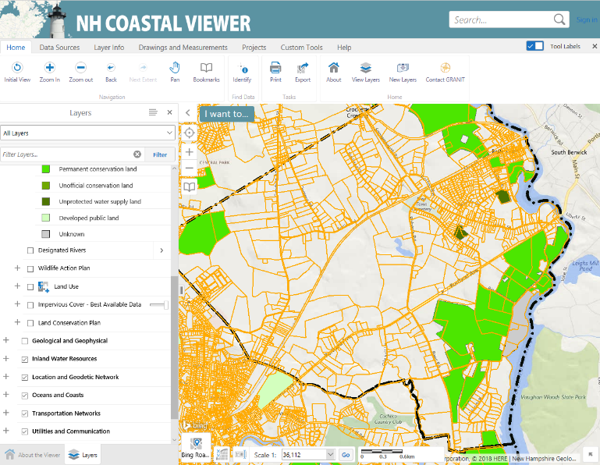
- Display the Conservation and Public Lands layer and the NH Parcel Mosaic Polygons. (Note: The parcel data has scale dependencies set so that it will only display if you are zoomed in sufficiently. If you selected a large town or area, you may need to zoom in further to see the features.)

Use the options in the Layer Actions menu to change the town boundary symbology to a thick black dash-dot line.

- Query the Conservation and Public Lands Layer

  - We are interested in parcels that abut large conservation tracts (e.g. tracts > 100 acres) for this conservation priority-setting exercise.

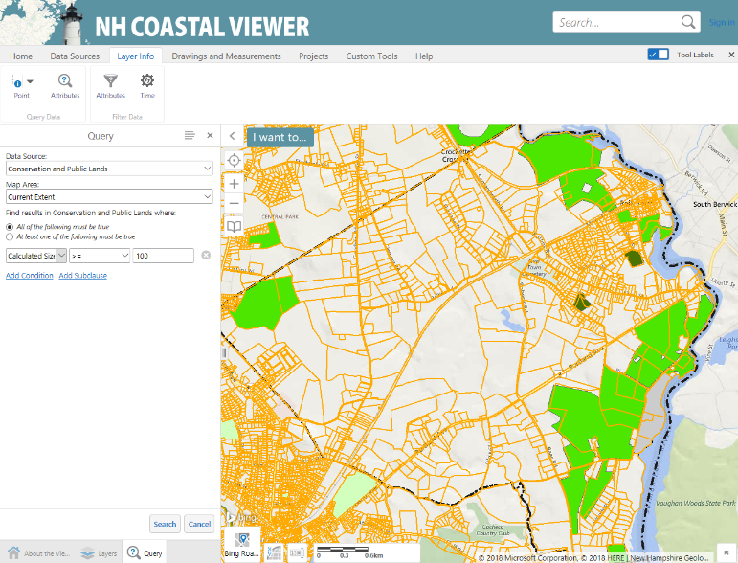
    - Click on the Layer Info tab and select the Attributes icon in the “Query Data” section.

    - Set the Data Source to “Conservation and Public Lands”, and the Map Area to “Current Extent”. To find the available attributes, click on the dropdown box. Select “Calculated Size”, then select “>=” as the operator and enter “100” as the value.

    - Click on “Search” at the bottom of the panel to apply the query.

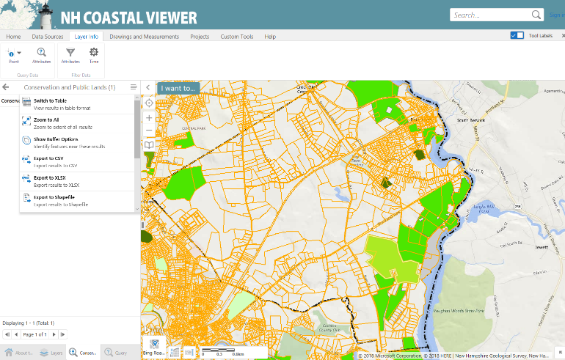
    - For Rollinsford, only one existing tract meets the condition, as highlighted in yellow. Note that the attributes of that tract are initially presented in the panel at the left.

    - To display the attributes in a standard horizontal table arrangement under the map, open the Panel Actions Menu and click on “Switch to Table”. When you are done scrolling through the attributes, close the table.

- Identify Abutting Parcels

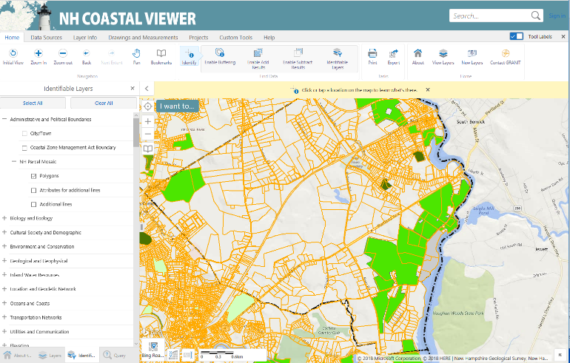
  - From the Home panel, use the Identify tool to identify the Parcel Mosaic polygon feature that coincides with this large conservation tract. The tool will identify all visible features at the location you point to, so we will restrict the tool to only identify features from our dataset of interest. First, click on “Identify” and then click on “Identifiable Layers”.

  - Click on “Clear All”, then click on the NH Parcel Mosaic Polygon data layer.

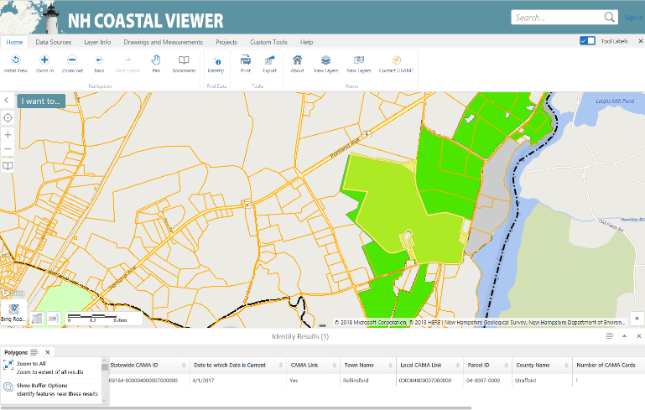

- Click on the large parcel of interest that coincides with the conservation tract. From the “Additional Actions” menu, select “Show Buffer Options”.

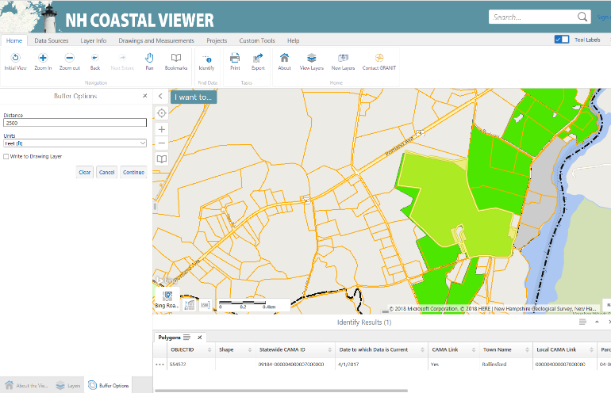

- Enter a Distance of “2500” and Units of feet, and then click on “Continue” to display all Parcel Mosaic polygons with 2500 ft. of the target polygon.

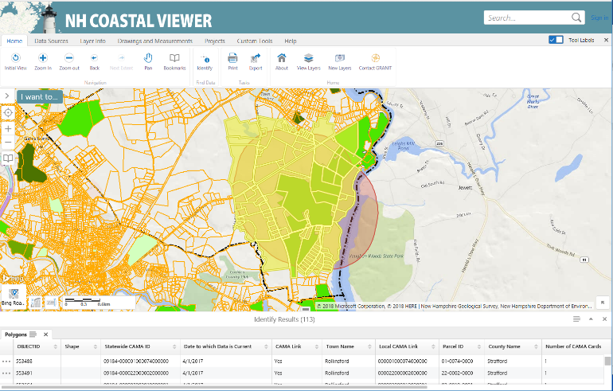
  - The map parcels that are within 2500’ of the polygon you identified are now highlighted in yellow. Their attributes are added to the table below the map. You can use the Parcel ID and other information listed to research ownership of the prioritized parcels.

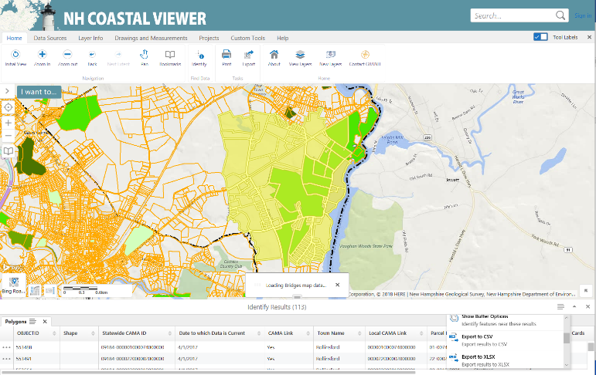

  - To export a tabular listing of the parcels identified, click on the Panel Actions menu and select “Export to CSV” or “Export to XLSX”.

As time permits, display additional data sets that might help you prioritize lands for future conservation efforts. Test your skills by displaying prime farmland soils from the Soil Series data set, based on the “farmlndcl” attribute!

